# Binomial distribution

Expected Value

$$E\left[X\right]=np$$

Proof:

Since X is sum of n identical Bernouli random variables, each expected value is p,

we have that

$$E\left[X\right]=E\left[X_{1}\right]+…+E\left[X_{n}\right]=p+…+p = np$$

Variance

$$Var\left[X\right]=npq$$

Proof:

$$Var\left[X\right]=Var\left[X_{1}\right]+…+Var\left[X_{n}\right]=p\left(1−p\right)+…+p\left(1−p\right)=np\left(1−p\right)=npq$$

PDF

$$f\left(k;n;p\right)=C_{k}^{n^{}}p^{k^{}}{\left(1−p\right)}^{n−k}$$

where

n: number of trials k:number of success p:probability of success.

CDF

$$F\left(k;n;p\right)=sigma\left(C_{i}^{n^{}}p^{i^{}}{\left(1−p\right)}^{n−i},i=1,i=k\right)$$

Mode

mode = $$floor\left(\left(n+1\right)⋅p\right)$$ if $$\left(n+1\right)⋅p ==0 or \left(n+1\right)⋅p is noninteger.$$

mode = $$\left(n+1\right)⋅p and \left(n+1\right)⋅p−1$$ if $$\left(n+1\right)⋅p belongs to \left\{1,2,…,n\right\}$$

mode = $$n$$ if $$\left(n+1\right)⋅p == n+ 1$$

Proof:

Let

$$f\left(k\right) =f\left(k;n;p\right)=C_{k}^{n}p^{k}{\left(1−p\right)}^{n−k}$$

For only

$$p == 0$$

, we have that

$$f\left(0\right) == 1$$

While for other any value of p,

$$f\left(0\right) == 0$$

On the other hand,

For $$p==1$$,

$$f\left(n\right)==1$$

$$f\left(k\right)==0$$ $$for all k!=n$$

Thus, when $$0<p<1$$, we have that $$\frac{f\left(k+1\right)}{f\left(k\right)}=\frac{\left(\left(n−k\right)⋅p\right)}{\left(k+1\right)⋅\left(1−p\right)}$$

From this follows,

$$k>\left(n+1\right)⋅p−1$$ => $$f\left(k+1\right)<f\left(k\right)$$

$$k==\left(n+1\right)⋅p−1$$ => $$f\left(k+1\right)==f\left(k\right)$$

$$k<\left(n+1\right)⋅p−1$$ => $$f\left(k+1\right)>f\left(k\right)$$

Median

If $$np$$ is integer, mean,mode,median $$==np$$

zss

$$floor\left(np\right)≤median≤ceil\left(np\right)$$

$$\left|median−np\left|≤\min\left\{\ln{2},\max\left\{p,1−p\right\}\right\}\right|\right|$$

Confidence Interval

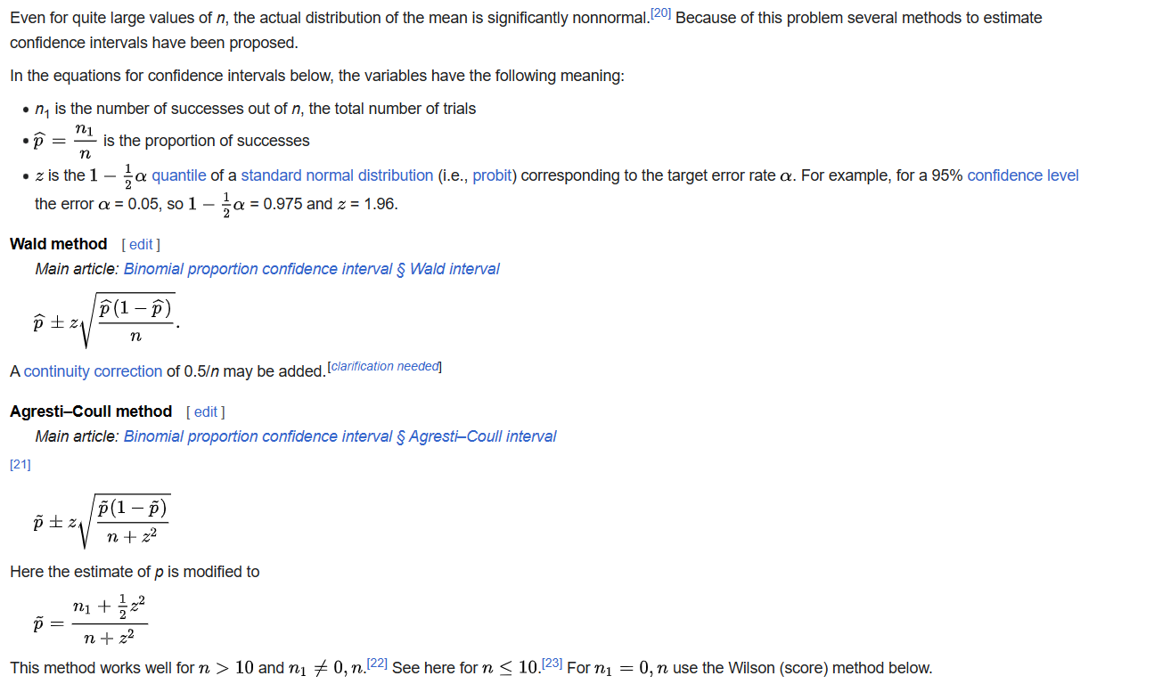

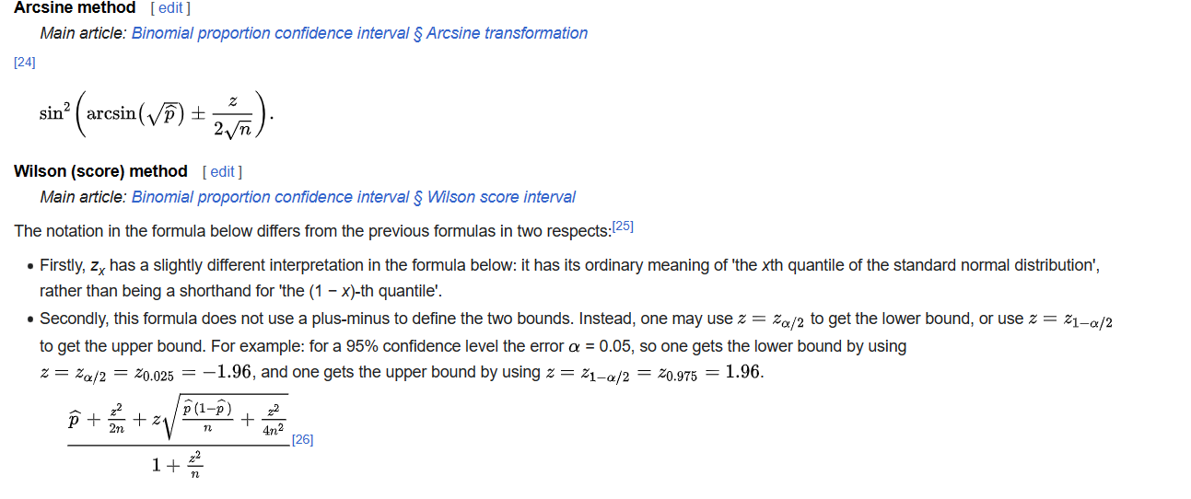

Ref

For introduction, see wiki:

[Binomial distribution - Wikipedia](https://en.wikipedia.org/wiki/Binomial_distribution)

For proof, see statlect:

[Binomial distribution | Properties, proofs, exercises (statlect.com)](https://www.statlect.com/probability-distributions/binomial-distribution)